C A R I B B E A N
M E T E O R O L O G I C A L
O R G A N I Z A T I O N

CARIBBEAN METEOROLOGICAL COUNCIL Doc. 10
FORTY-EIGHTH SESSION
Georgetown, GUYANA, 1-2 DECEMBER 2008

OTHER PROJECT UPDATES AND PROPOSALS
(Submitted by the Coordinating Director)

Introduction

1. Weather, climate and water are at the heart of the environmental issues affecting the planet. Meteorological and Hydrometeorological Services (NMHSs) in the Caribbean and the world over must provide accurate information, analyses and timely forecasts of hazardous weather-related conditions that affect the sustainable development of their nations in the short term. At the same time, the NMHSs must provide the appropriate data and scientific-basis for studies on the long-term potential impacts of both natural and human-induced climate changes on the environment. The contribution of meteorology and related sciences to these global studies is driven by the constant adaptation to and use of technological changes and opportunities.

2. In this regard, many of the projects being undertaken or planned have observational and scientific data information components involving the use of new or modern technologies. This is primarily an information document intended to keep the Council up-to-date on the progress of implementation on any on-going projects of this nature, which involve CMO Member States and partner organizations, such as the World Meteorological Organization (WMO). The document will also inform the Council and seek its guidance, on proposals for new projects.

(a) WMO CARIB-HYCOS PROJECT IMPLEMENTATION

3. In 1993, the WMO launched the World Hydrological Cycle Observation System (WHYCOS). Its aim is the development of water resources information systems to assist Member countries to improve their water management, mitigate the impact of water-related disasters such as floods and droughts and contribute to regional and global studies of the impact of climate change on water resources. WHYCOS is being developed through a series of regional HYCOS components. Some 16 HYCOS projects are at varying stages of development and implementation in various regions of the world; Carib-HYCOS is one of these projects. The Carib-HYCOS component had been proposed as two components, one addressing the needs of the Caribbean Island countries (CIC) and the other, the needs of the mainland countries of the Caribbean Basin. Draft project framework documents for both components, prepared by WMO, had been circulated to the countries concerned and were first made available to the Council at its 40th session (Barbados, 2000).

4. The specific aims of the Island Component of the Carib-HYCOS Project are the reinforcement of national capabilities in water resources management and promotion of international cooperation (exchange of data, technology and expertise). As a regional institution, the CMO has been supporting Carib-HYCOS, particularly to ensure that the CIMH plays an integral part in this important activity. Interest surfaced in the Islands Component early in the process but it was only in 2007 that all relevant agreements for the implementation were signed. The implementation phase began in the first half of 2008. As reported to earlier sessions of the Council, the CMO Member States that expressed interest in participating in the Project and which took part in the preparatory phase are Barbados, Jamaica and Trinidad and Tobago. Some other CMO Member States that could benefit had never actually indicated their interest prior to the start of implementation.

5. The WMO is the Supervising Agency of the Project, while the Institut de Recherche pour le Développement (IRD) of France is the Executing Agency. IRD hosts the Project Regional Center (PRC) in Martinique, including the Project Management Unit (PMU) and a server for a regional database. The PMU will be assisted by the Caribbean Institute for Meteorology and Hydrology (CIMH) and the Instituto de Meteorologia (INSMET, Institute of Meteorology) of Cuba for the English- and Spanish-speaking countries respectively.

6. During the preparatory phase:
- a consultative meeting between WMO and IRD was held at the WMO Secretariat in Geneva in February 2008;
- a questionnaire was circulated and country visits completed during the months of April and May 2008; and
- a consultation meeting was held in Martinique in June to analyze the outcome of the country visits and to complete the preparatory phase, including:
  - confirmation of commitment by participating countries;
  - names and addresses of Steering Committee members;
  - an agreement on data exchange and dissemination.

7. The first meeting of the Steering Committee took place in Martinique from 21-23 October 2008. The CMO Headquarters and the CIMH were represented on the Steering Committee, as well as participating countries. The Steering Committee reviewed the detailed project document, and finalized the work plan and budget. At the end of 2007, the Project was being co-financed by three donors for a total of €1,317,000 as follows:
General Council of Martinique: €540,000
Regional Council of Martinique: €250,000
European Funds for Regional Development (FEDER): €527,000 (to the end of 2008).

8. Since the Project implementation started in 2008, only a small part of the FEDER funds could be utilized. Therefore, the available donor funds from was reduced to €840,000. In addition, the Project estimated in-kind contributions of €1,200,000 from IRD and €400,000 from participating countries.

9. Based on the reduced budget, the Steering Committee decided on:
- The type and number of standard sets of Hydrological Equipment for each country. Each standard set will include an automatic rain gauge, automatic water level sensor and a data logger with transmission. Most countries will also receive water quality monitoring equipment. GSM/GPRS was identified as the most suitable system for data transmission.
- Options for a Data Management System. It also agreed that, whatever Database Management System was eventually purchased, countries could continue, if desired, to use their existing database structure.
- The outline of a Training Programme to improve human capacity in the National Hydrological Services (NHSs). Based on topics requested by countries and in accordance with WHYCOS Guidelines, eight modules were identified for inclusion in the Training Programme, subject to availability of funds. Two modules were considered for training sessions in 2009 and 2010. Use will be made of the considerable amount of training material already developed as part of other HYCOS projects around the world.

10. During the Project Steering Committee meeting, an opportunity was presented to apply for additional funds that would compensate for and possibly even surpass the loss of the FEDER funds, but applicable to a second or subsequent phase of the Project. The European Union’s “INTERREG IV - Caribbean" programme, designed for Guadeloupe, French Guiana, Martinique and new Overseas Communities of Saint-Barts and Saint-Martin, was approved in March 2008. Its objectives include “Enhance cooperation across borders through joint local and regional initiatives”. The deadline for application for these funds was 28 November 2008. The PSC agreed to apply for additional funds from INTERREG and, if new funds became available, proposed to include the other English-speaking countries not yet participating (such as Dominica, St Lucia, Antigua,…) if they showed an interest to participate. The CMO Headquarters, in collaboration with the CIMH, has been assisting those CMO Member States in their decisions on participation.

(b) CAYMAN ISLANDS RADAR PROJECT PROPOSAL

11. CMC48 Doc.9 gives details of the status of implementation by the Caribbean Meteorological Organization of a 13.2 million Euro Project, funded by the European Union, to establish a new, modern and expanded radar network in collaboration with other countries in the Caribbean, as part of the regional early-warning system. The new radar network will stretch from French Guiana, along the South American coast to Trinidad, then north along the Eastern Caribbean Islands, then westward across the Greater Antilles to Jamaica and to Belize in Central America. The previous two sessions of the Council have been informed that the CMO Headquarters made a proposal to the Government of the Cayman Islands to plug the one glaring gap in the radar coverage; that is, the gap around the Cayman Islands.

12. The Government of the Cayman Islands has recognized the urgent need to fill that gap in the radar network. In March 2008, the CMO presented a comprehensive project document to the Government for its consideration and, at the time of preparation of this document, the CMO was awaiting a decision on its proposal. A new Doppler weather radar would form the centrepiece of the Cayman Islands early warning system and would be integrated into the full CMO network, as depicted in Figure 1.

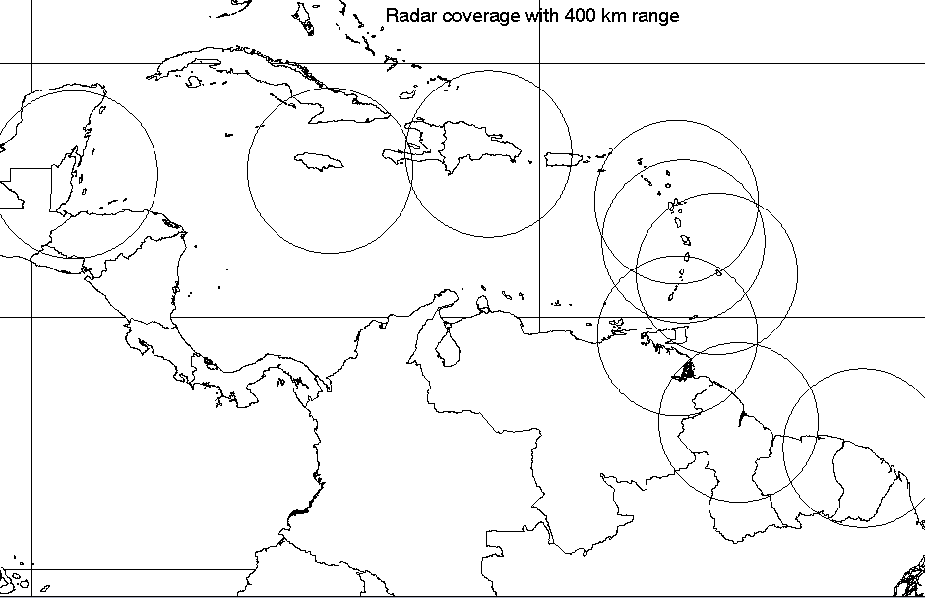
Belize
Jamaica
Dominican Rep.
Guyana
Fr, Guiana
Guadeloupe
Trinidad
Barbados
Martinique
Cayman Isl.

Figure 1: Proposed Radar for the Cayman Islands to provide complete Caribbean radar coverage

(c) FUTURE CMO PROJECT PROPOSALS

13. In addition to projects above, the CMO Headquarters is proposing to organize or participate in several projects in the near future aimed at reviewing, updating, improving and even widen the observational networks and data collection in the Caribbean, to ensure the constant availability of the highest quality data. A few non-observational activities are also in the pipeline. A brief description of these follows:

(i) Lightening Detection System
14. For several years, the CMO and Météo-France (MF) have expressed the desire to collaborate in the establishment of a Lightening Detection System in the region, but it was not actively pursued because of the activities of the Radar Project. Some of the methodologies and costs of establishing such System have been discussed. For example, a determination would be needed on whether to establish an NMS-operated system vs utilizing a privately-run system at an annual operating fee. In one proposal already received, the cost was in the region of 800,000 Euros for the purchase of a European-built network of six sensors, versus 100,000 Euros for an annual lease with at least 4 customers. CMO and MF agreed to study this in greater detail after the completion of the Radar Project. Figure 2 shows lightening detection using technology that gives a broad idea of the lightening strikes, but this is not nearly as accurate and available, as is needed in the region.

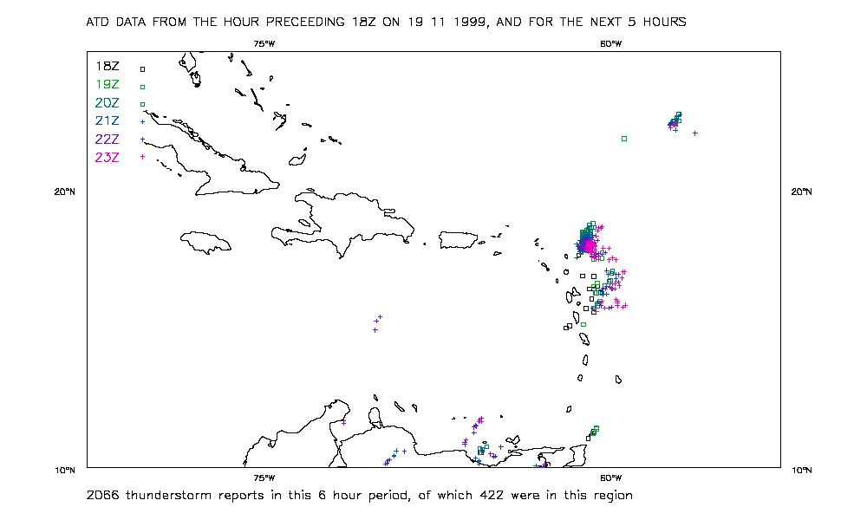

Figure 2: Broad scale lightening detection

(ii) Continental river runoff observations in Guyana and Belize
15. Daily hydrological runoff observations at downstream ends of large continental rivers are necessary for monitoring the global freshwater flux into the oceans. This is an important contribution to global climate change studies. Avenues will be explored to begin collecting such data in the rivers of Belize and the large rivers in Guyana. This could be handled in association with GCOS (Global Climate Observing System) activity or under a continental WMO-HYCOS project.

(iii) Coordination of CMO Automatic Weather Station data collection
16. There are many Automatic Weather Stations (AWS) operated by the NMHSs in CMO Member States that are not all available in an operational mode, or are not shared through the WMO Global Telecommunication System (GTS). This is partly a telecoms issue. The remote nature of some AWSs may also pose maintenance challenges that need to be addressed. There is a need for proper quality control of AWS data, including the availability of the data to all users & proper archiving for operational and climate use. A project for this matter may not require outside financial assistance but could be coordinated with local funding.

(iv) Development of a new Meteorological Service in the Turks & Caicos Islands
17. Meteorological observations in the Turks and Caicos Islands are carried out in an ad-hoc manner, primarily in support of Civil Aviation. However, there is currently no formal observation network, nor adequate data collection, storage and use of conventional meteorological data, ocean data, etc. There is a very urgent need for a new internal structure that will undertake official weather and related observations that will contribute to all segments of society. The TCI authorities and the CMO are working on plans for implementation in the very near future.
(v) Data Rescue
18. Through several projects and programmes over the last decade, attempts have been made to rescue old meteorological and climate data. Most of the old data exists in paper form that runs serious risks of damage or even loss. Data rescue efforts are aimed at saving these important data sets by converting them to a digital format for storage and retrieval. Data Rescue equipment, software and training have already been provided to the NMHSs of CMO Member States. However, data rescue efforts are still far from achieving the aims of the climate community. The CMO’s aim is to continue existing programmes to capture old data from both traditional and non-traditional sources. Non-traditional sources would include data collected by non-meteorological national entities, as well as from the many old British and US military bases in the Caribbean and the US Weather Bureau stations in the Caribbean. Data rescue efforts should continue at the national level, but the CMO will also explore linking these efforts to larger international data rescue programmes, such as those of the GCOS within for Central America and the Caribbean.

(vi) Metadata Collection Project
19. The term “metadata” means “data about data” of any sort and in any medium. Metadata gives all levels of detail of data collected, of the instruments used, methods of storage, ownership, etc. For example, metadata describes how, when and by whom a particular set of data was collected, how the data elements are formatted (name, size, data type, etc) and structured (length, fields, columns, etc). Metadata exists on most of the conventional weather observing stations at NMHSs in CMO Member States. But there needs to be an assessment to check the completeness of this metadata. In recent years, there have been a large number of Automatic Weather Stations (AWS), hydrological stations, sea level monitoring stations, etc that have been installed in the Caribbean. Metadata on these stations has not been properly documented, if at all. In some cases, both old and new stations, or parts thereof, have been moved to nearby locations, without any documentation of the move being recorded.

20. In the context of weather, water and climate studies, the metadata on individual sensors is necessary. From a data processing perspective, metadata is critical to the “globalization” of data exchange. The new WMO Information System (WIS), of which the traditional GTS now forms a core, is based on a multiple-level database system that relies on accurate metadata.

21. There are a number of regional and international activities being planned or implemented to improve the availability of metadata. The CMO Headquarters plans to contribute to the effort by introducing the methodology to the NMHSs in CMO Member States to generate a complete list of existing regional installations and associated metadata.

(vii) Marine Meteorology Improvements
22. It is the view of the CMO Headquarters, there is a large variation and/or disparity in the capabilities of NMHSs in the Caribbean in the area of marine meteorology. The CMO Headquarters does not believe that the marine sector has received sufficient emphasis in the application of meteorology, in terms of observations, forecasts and warnings. Greater emphasis in this area is urgently needed. The CMO has already initiated preliminary discussions with the WMO and the Intergovernmental Oceanographic Commission (IOC) of UNESCO with a view to exploring methods of improving this service in the Caribbean. The CIMH will need to be involved in this effort as it is envisaged that new training methodologies will need to be introduced into its regular training programmes. The CMO Operational Meteorology Advisory Group (COMAG) will also need to be involved in assisting in the introduction of new techniques at the operational level.

- Radar-related Projects
- Under the CMC48 Doc 9 on the EU-funded CMO Weather Radar Project, it was noted that once the new weather radars were fully operational, there are two radar activities that need to be undertaken:
  - Radar Calibration: There is a requirement to undertake the meteorological calibration of the radars against ground-based rainfall networks at different times of the year. A project involving the Meteorological Service of the radar countries and the CIMH will be needed to undertake the calibration of each radar. This will be a major activity that will require the collaboration and involvement of local hydrological and agrometeorological agencies that also operate rainfall networks. The CMO will explore the methodologies of this calibration with all parties in 2009.
  - Radar Emission Survey: It can be shown mathematically that the microwave emission from weather radars easily conform to international health and safety standards. Information on the emissions was also provided by the radar manufacturers. However, recognizing that the term “radiation” has certain connotations for the public, The CMO Headquarters intends to commission a survey by an independent and reputable institution to test and verify the conformity of the radar emissions to international health and safety standards. The CMO will have to seek local or external funding support for this activity in the near future.

ACTION PROPOSED TO COUNCIL

24. The Council is invited to:

Note the updated information and provide any further guidance on (i) WMO Carib-HYCOS Project, (ii) The Cayman Islands Radar Project Proposal and (iii) Future projects planned by the CMO Headquarters.

_____END_____

CMO Headquarters
November 2008

